Modelling sediment resuspension/erosion.

1. Power law (based on field experiments by Lavette et. al. 1984)

$$E= α{\left|τ\right|}^{q}$$

Where E is the erosion rate, tau the bottom shear stress, alpha = ? and q some value

[tau] = N/m^2

1. Empirical pickup function by Van Rijn (1966)

Van Rijn, L. C.: 1966, Applications of sediment pick-up functions, J. Hydr. Eng., ASCE 110, 507– 514.

1. [From Jin 2004 – Case study: modeling of sediment transport and wind-wave impact in lake Okechobee]:

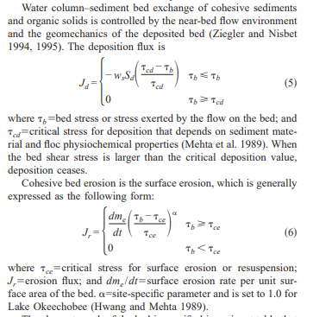

From all the articles I’ve read on the subject one thing is clear: in order to more accurately model the sediment resuspension, the bottom shear stress on the lake floor (tau) from water turbulence needs to be calculated.